Rabbit Project
Mrs. Heiney
Email: acwright@conroeisd.net

If you are thinking about raising a rabbit project, you need to take a few things into consideration. The meat rabbit project consists of having at least 2 females and 1 male, that way you have more babies to choose from when it comes time to show the babies. You can keep the breeding stock for future litters. You will pick out the top three offspring and show a meat pen of rabbits. If you decide to raise rabbits you will need to feed and check on them twice a day at the same time each day. You will not want to handle the babies too much, but enough that they can be picked up by the judge and sit on a table. Mrs. Heiney will teach you how to get them to do this. It is your responsibility to follow through with what you are instructed to do. You will want your animal to have fresh water daily so make sure you change the water EVERYDAY. You need to weigh the babies every week and more frequently as the show gets closer. You can record your weights on the board in the barn. We will monitor the food intake and add any supplements if needed. The goal with the babies is to get them as close to 5 1/2lbs on show day and as consistent as possible. You will get instruction on how to do this as well.

Cost – approximately $75 per rabbit (breeding age)
Barn fee- See barn policies and procedures*
Feed – Blue bonnet rabbit feed
Supplies: Available at Sullivan's Supply
My Feedstore and More Conroe,tx
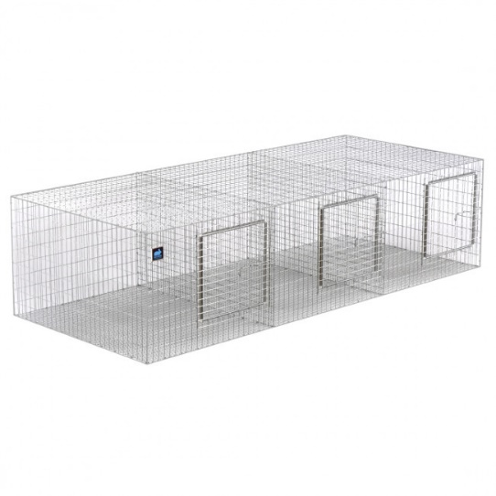
Conroe Feeders Supply
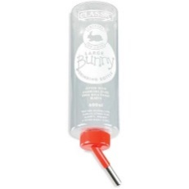
Water bottles
Food bowls
High quality Hay
Enough hutches to separate rabbits
Nesting boxes for breeding does
